Test Case: tc001_SPX_Dev5_Crear_Solicitud_Articulo_Almacen
Step 1 - Enter username and password and click to button Enter : Credentials Entered
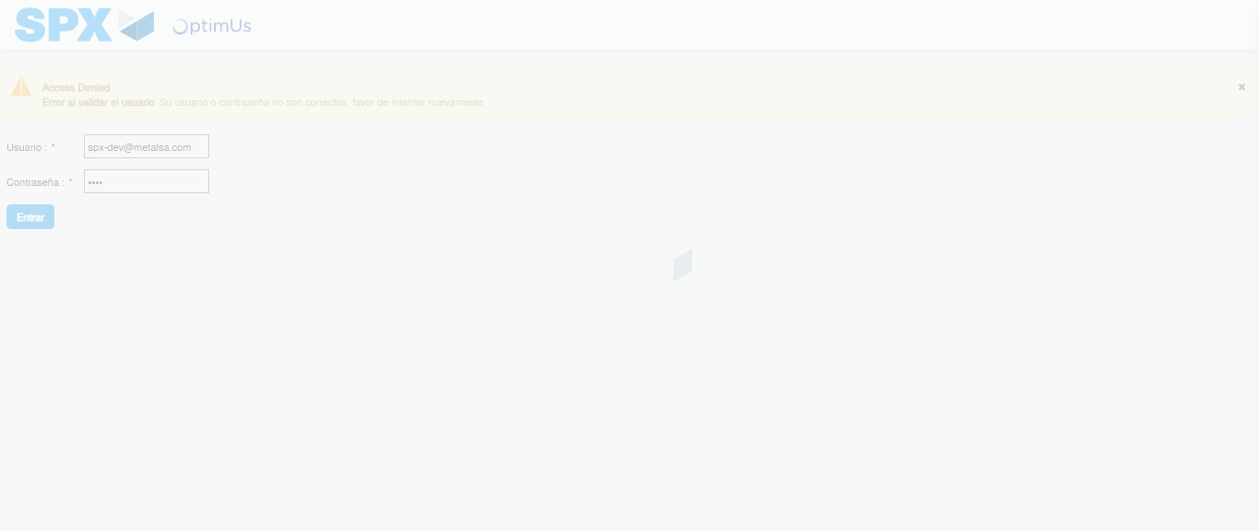Image file-name: QC_Testing-tc001_SPX_Dev5_Crear_Solicitud_Articulo_Almacen-1787931963796

Step 2 - Select to UEN and Access to Request for a New Inventory Item : UEN Correctly selected and Correct access
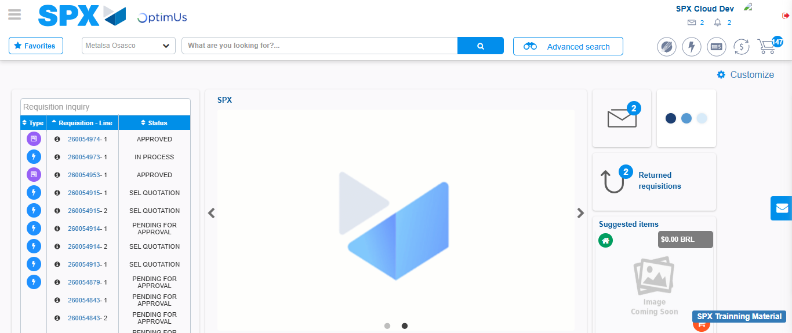Image file-name: QC_Testing-tc001_SPX_Dev5_Crear_Solicitud_Articulo_Almacen-1787931989557

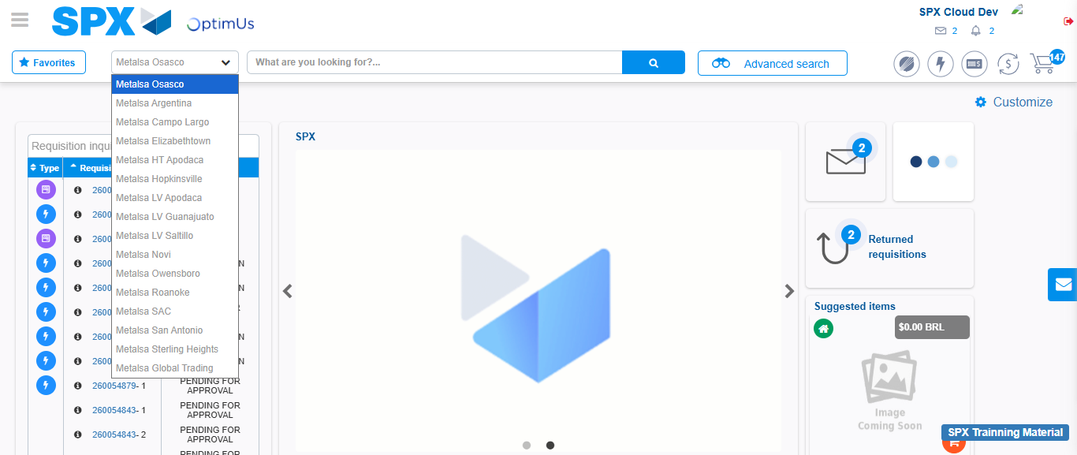Image file-name: QC_Testing-tc001_SPX_Dev5_Crear_Solicitud_Articulo_Almacen-1787931990052

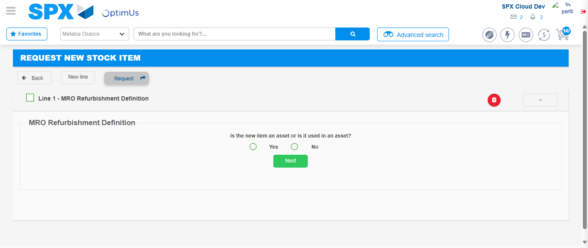Image file-name: QC_Testing-tc001_SPX_Dev5_Crear_Solicitud_Articulo_Almacen-1787932013646

Step 3 - Select options first section : Options seleted correctly
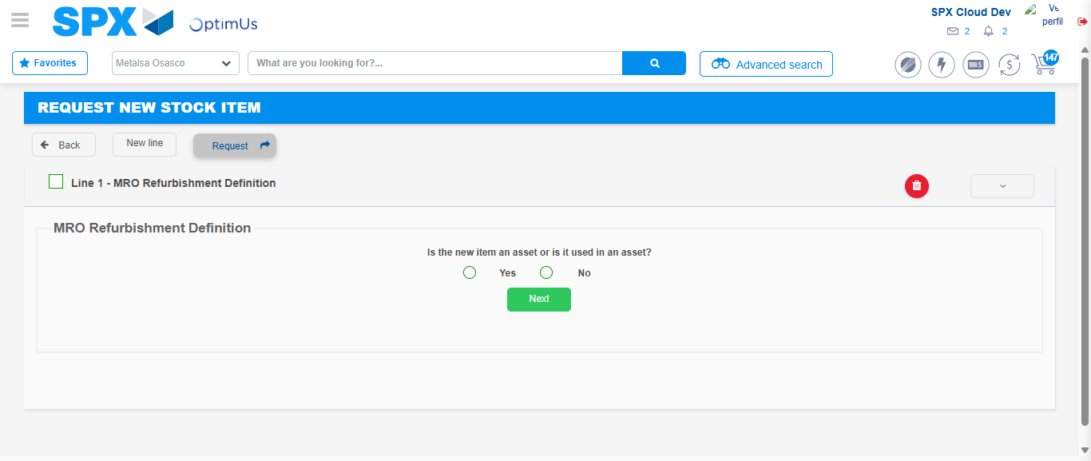Image file-name: QC_Testing-tc001_SPX_Dev5_Crear_Solicitud_Articulo_Almacen-1787932013952

Image file-name: QC_Testing-tc001_SPX_Dev5_Crear_Solicitud_Articulo_Almacen-1787932014156

Step 4 - Select options at Screen: Options seleted correctly
Image file-name: QC_Testing-tc001_SPX_Dev5_Crear_Solicitud_Articulo_Almacen-1787932013952

Image file-name: QC_Testing-tc001_SPX_Dev5_Crear_Solicitud_Articulo_Almacen-1787932014156

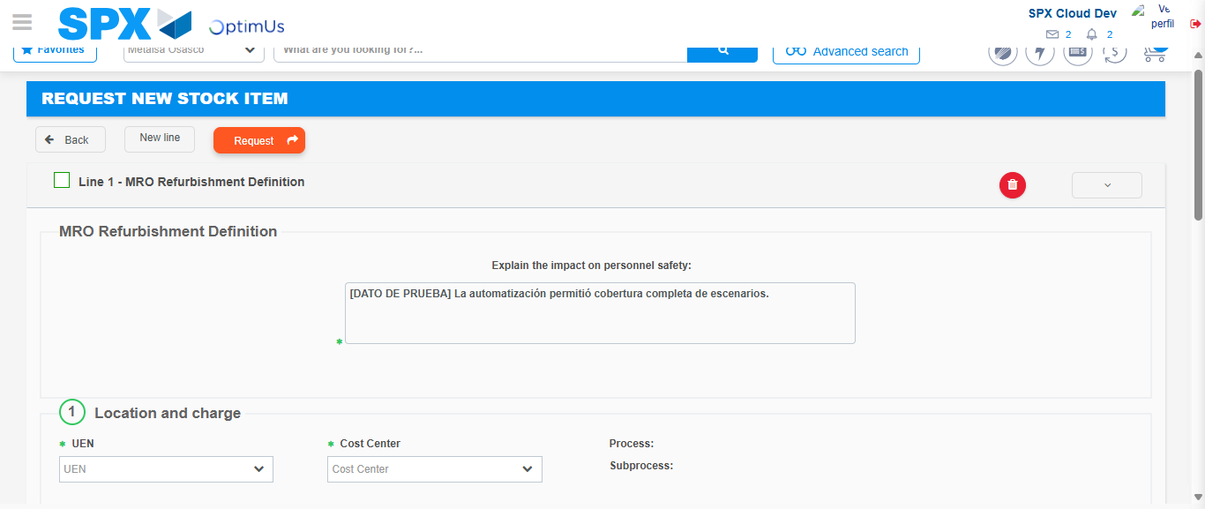Image file-name: QC_Testing-tc001_SPX_Dev5_Crear_Solicitud_Articulo_Almacen-1787932020545

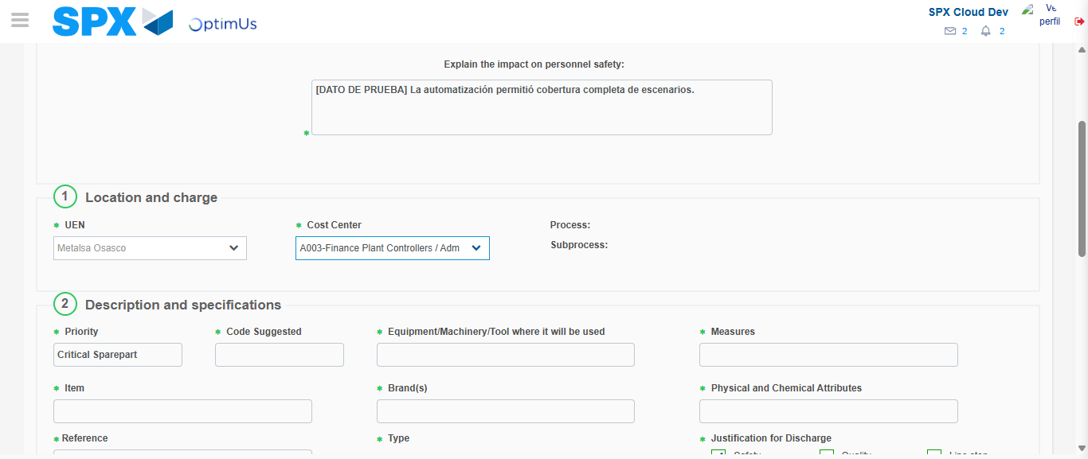Image file-name: QC_Testing-tc001_SPX_Dev5_Crear_Solicitud_Articulo_Almacen-1787932023207

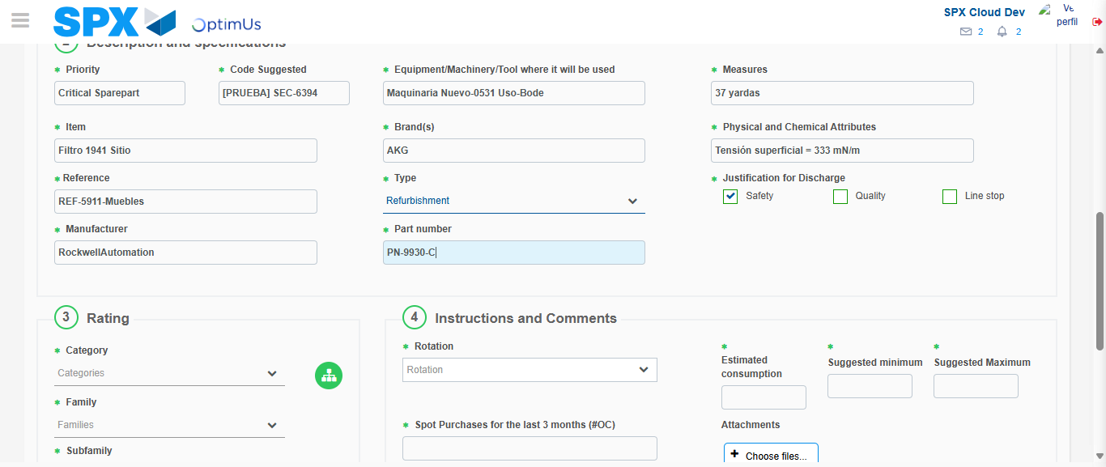Image file-name: QC_Testing-tc001_SPX_Dev5_Crear_Solicitud_Articulo_Almacen-1787932024750

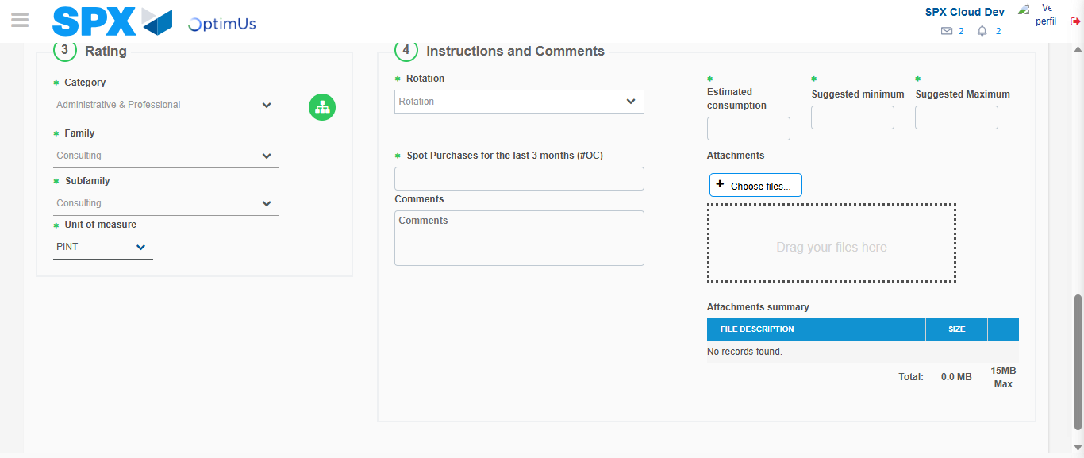Image file-name: QC_Testing-tc001_SPX_Dev5_Crear_Solicitud_Articulo_Almacen-1787932029765

Step 5 - Request New Item : Request Accepted
Image file-name: QC_Testing-tc001_SPX_Dev5_Crear_Solicitud_Articulo_Almacen-1787931989557

Image file-name: QC_Testing-tc001_SPX_Dev5_Crear_Solicitud_Articulo_Almacen-1787931990052

Image file-name: QC_Testing-tc001_SPX_Dev5_Crear_Solicitud_Articulo_Almacen-1787932013646

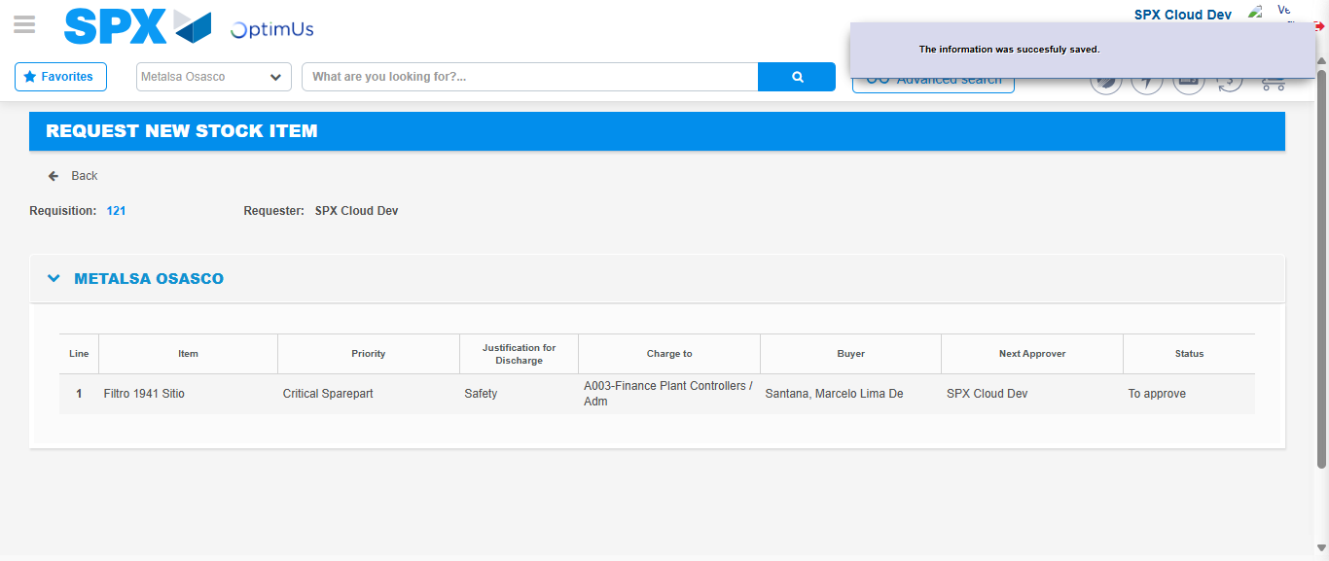Image file-name: QC_Testing-tc001_SPX_Dev5_Crear_Solicitud_Articulo_Almacen-1787932036461

Image file-name: QC_Testing-tc001_SPX_Dev5_Crear_Solicitud_Articulo_Almacen-1787932036587

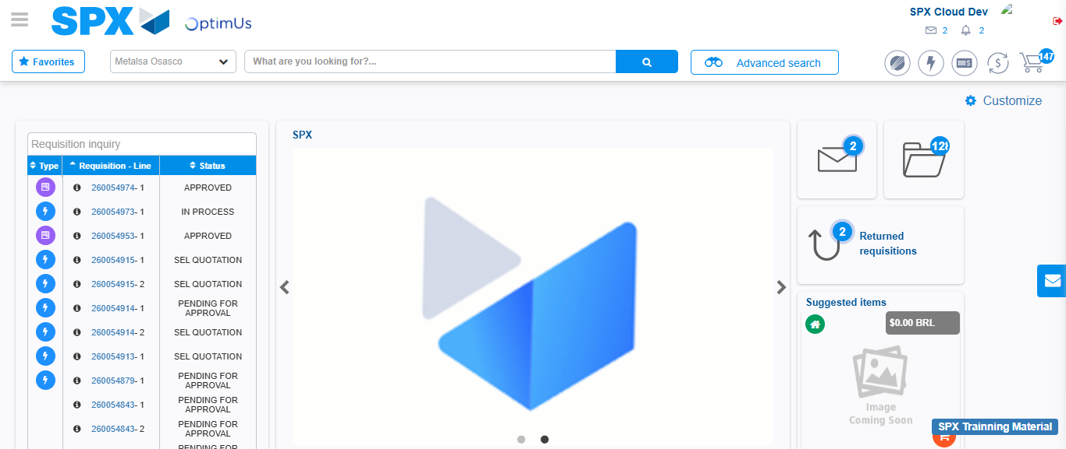Image file-name: QC_Testing-tc001_SPX_Dev5_Crear_Solicitud_Articulo_Almacen-1787932057779

Step 7 - Return to Main Page SPX : Return to Main Page SPX
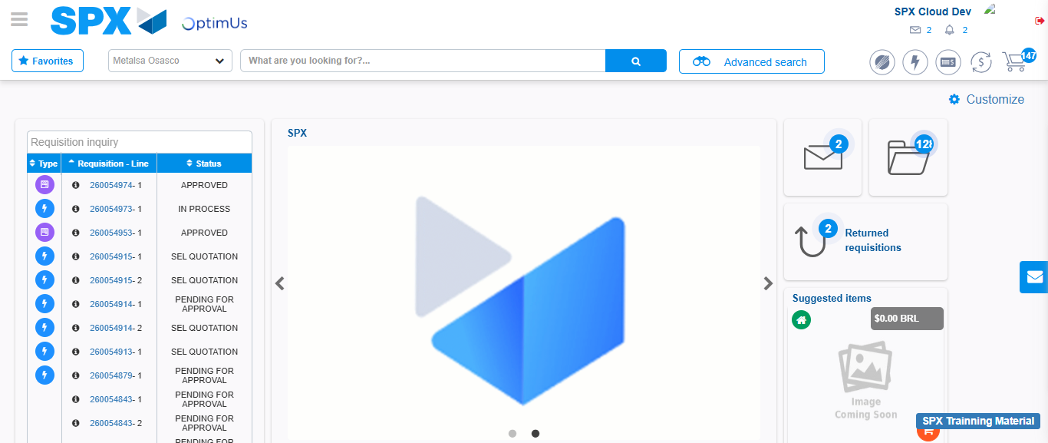Image file-name: QC_Testing-tc001_SPX_Dev5_Crear_Solicitud_Articulo_Almacen-1787932058058

